Week 15 - Northwind - DB_First

API:

Step 1: Install needed Packages In API :
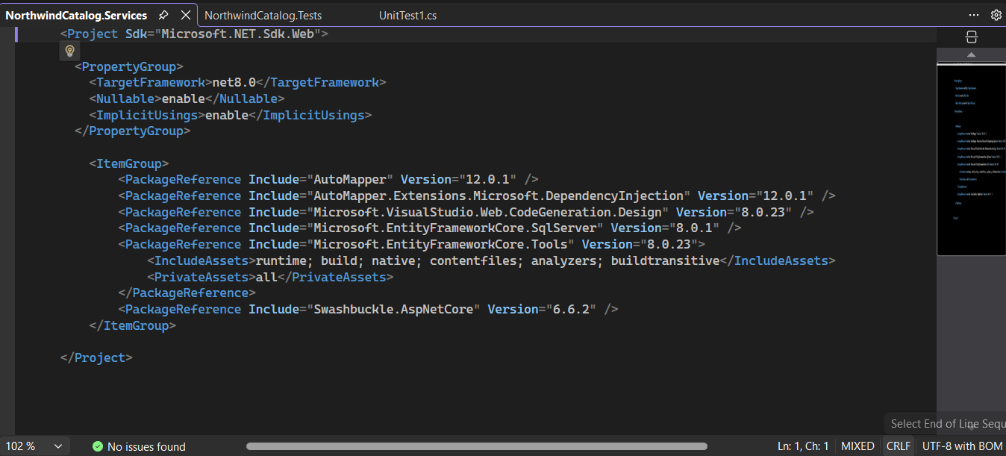

Step 2: Connection String Implementation
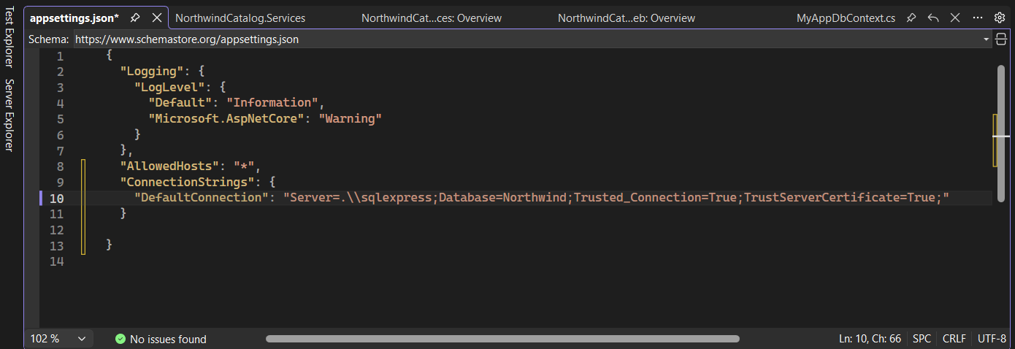

Step 3: Command to Get the Model and Dbcontext file from database
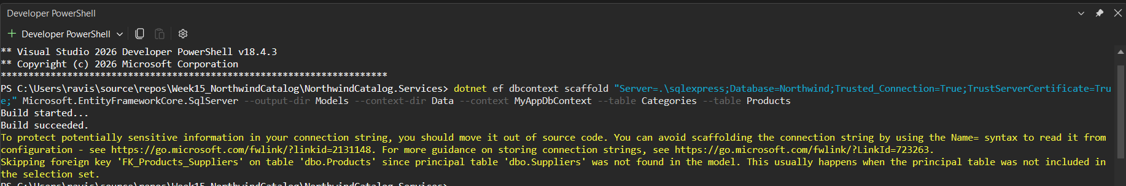

Step 4 : Creating controller with API- EF core
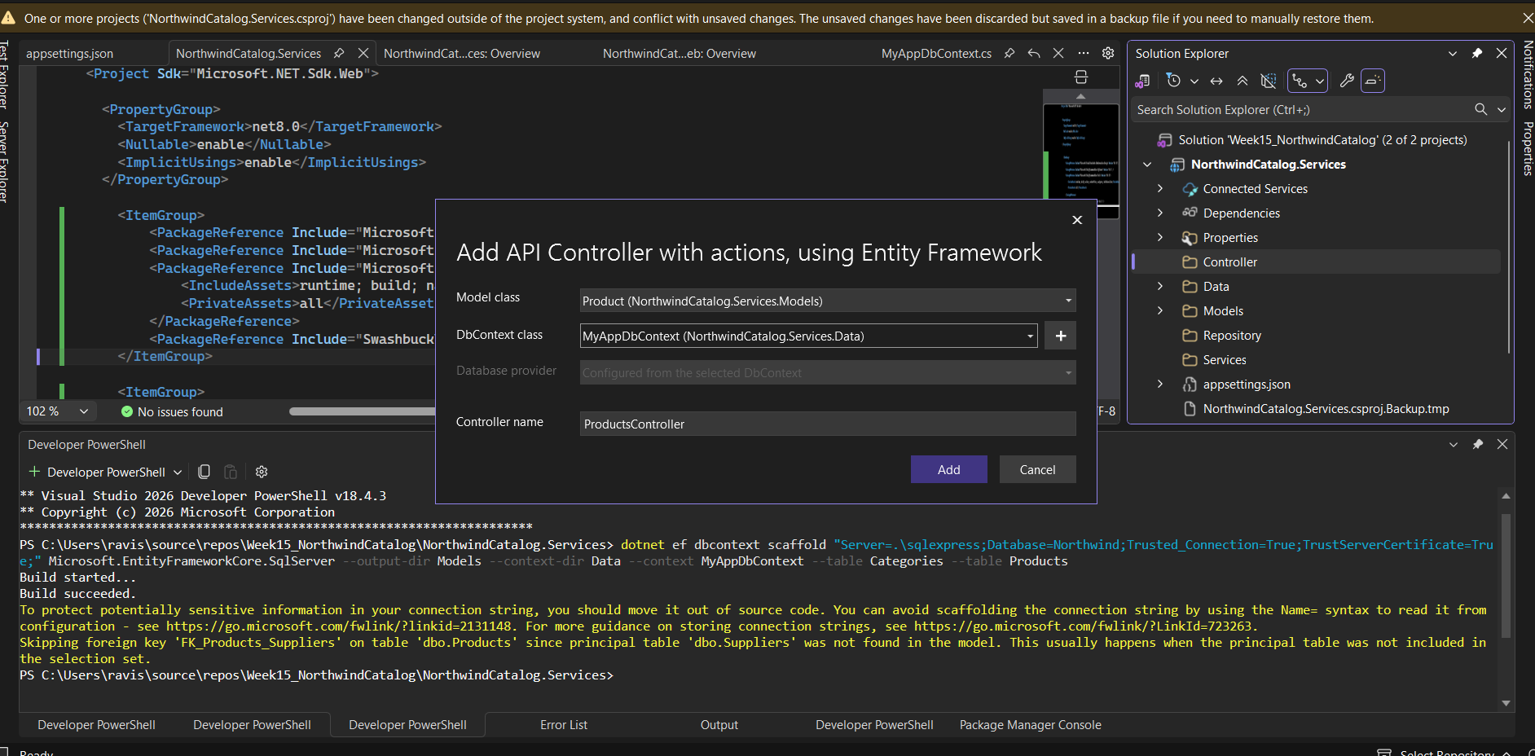

Step 5: Modefing My Program.cs file
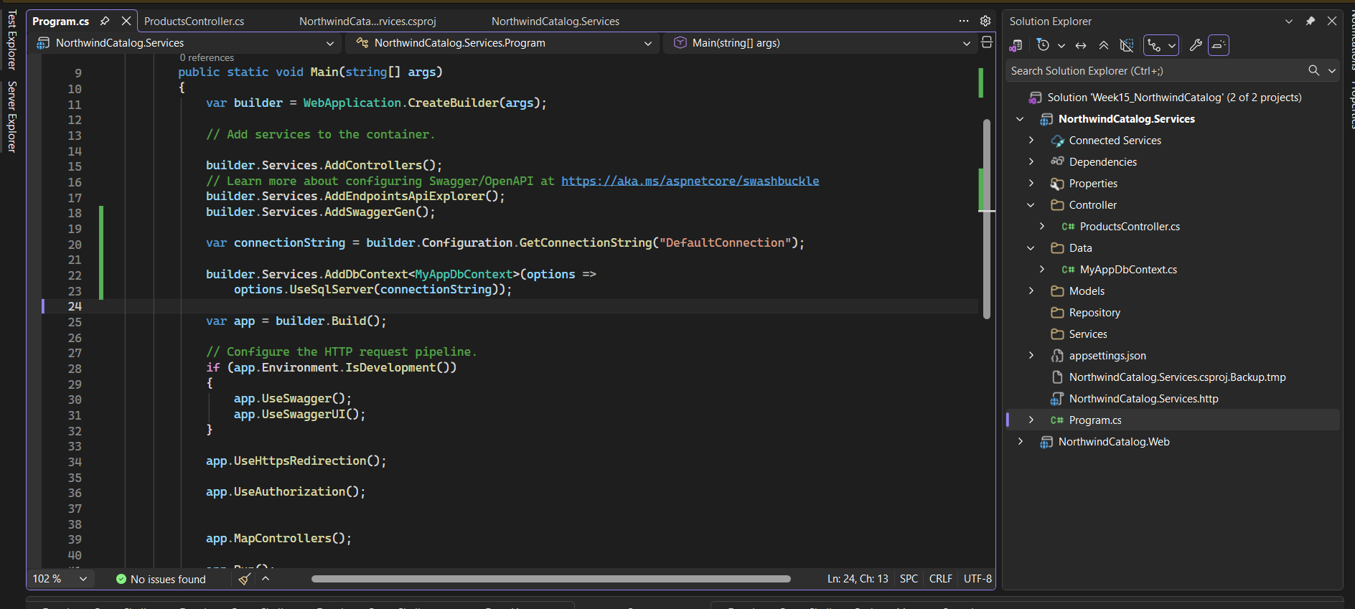

Step 6: Create Controllers, Repository and DTO
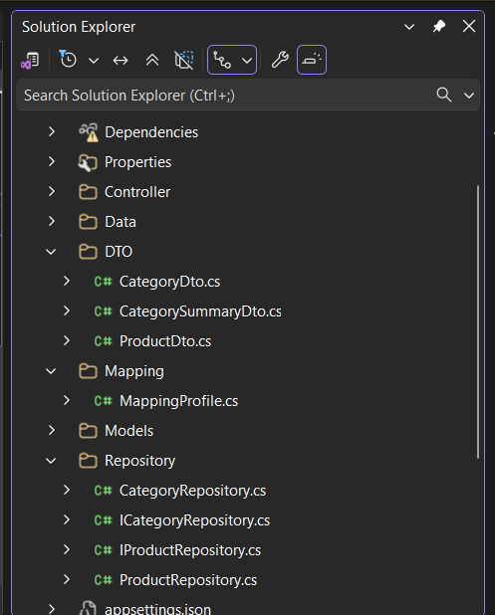

Step 7: Check Your API on Swagger

Web:

Step 1: File structure

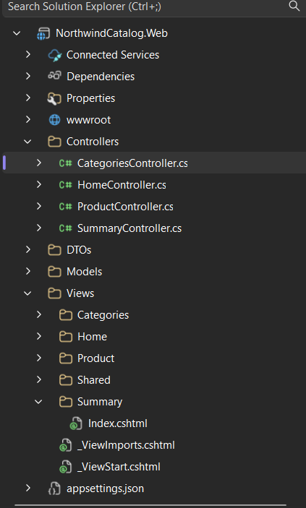

Step 2: Add HttpClient Connection in web program.cs
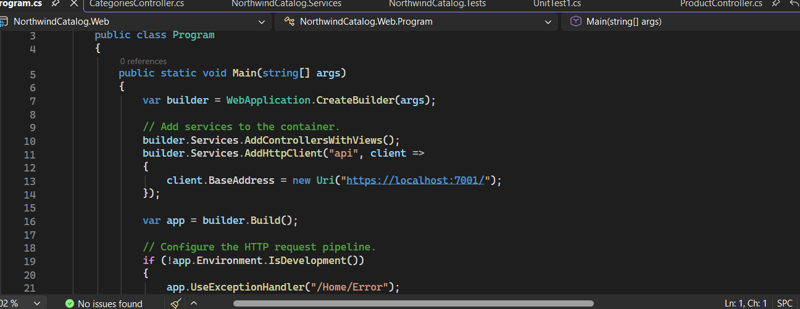

Step 3: Now Create Controllers and use Dependacy Injection
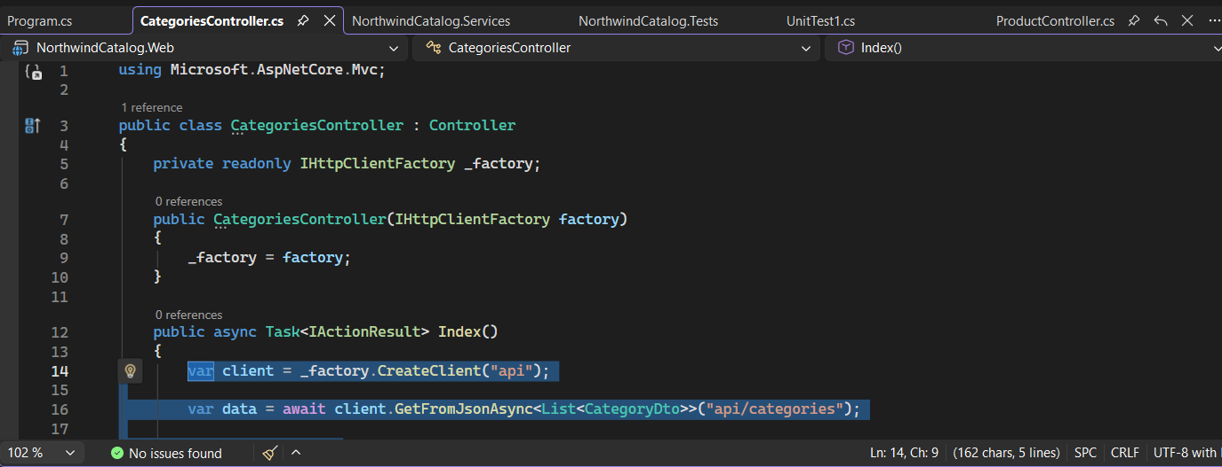

Step 4: Create Views for all of your Action Method
Step 5: use BootStrap To improve the UI/UX of your website Page

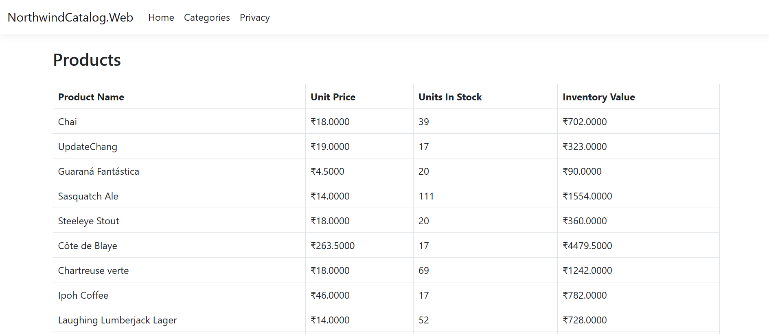

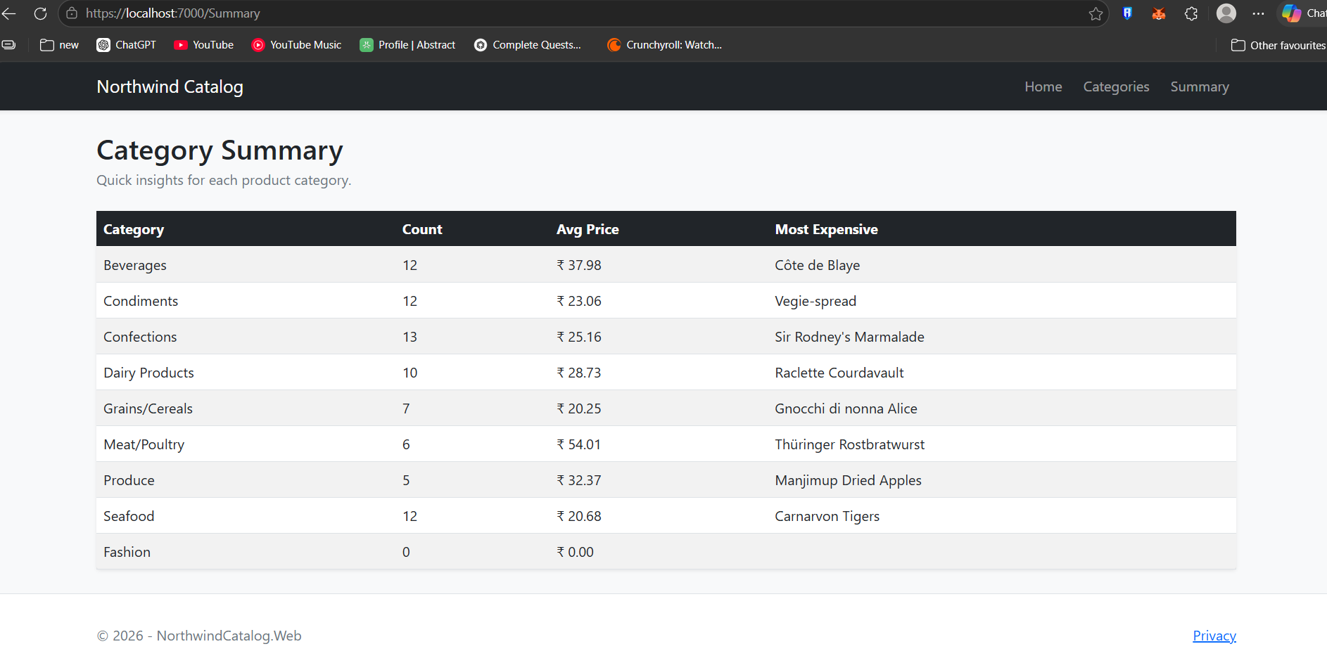

Testing:

Create a xUnit project
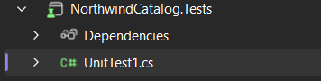

Create a Seniro to check the testing
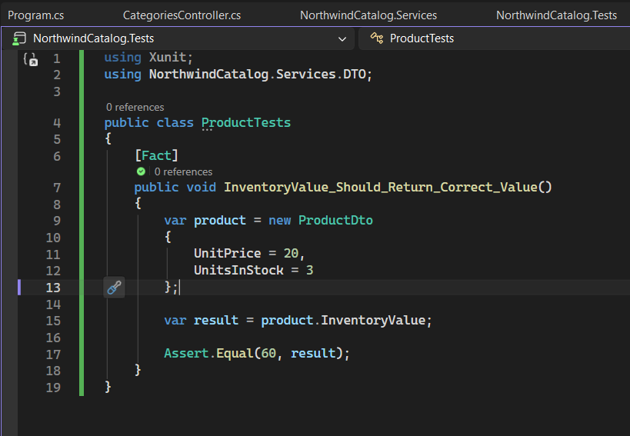

Check your testing
